You can create separate files for application.yml and one for dev and one for production, it will give you more edge for testing and dev. Keeping common things in application.yml and different in different.

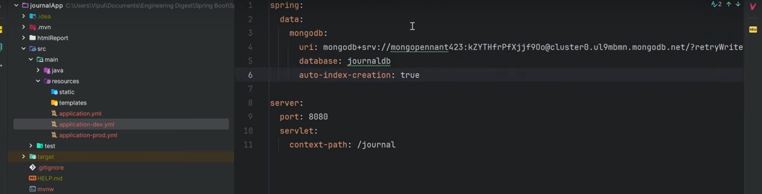

As we have written tests in our application so we can’t make jar file direct, specify the application properties file in order to use it.

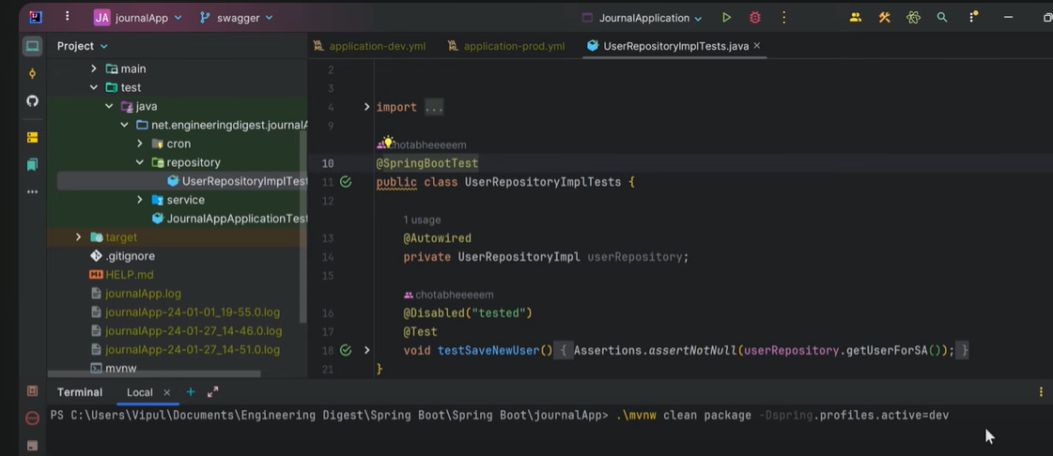

To fetch active profiles on our running project

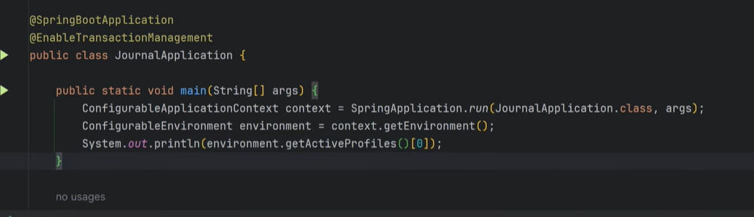

You can have two active profiles at a time as well

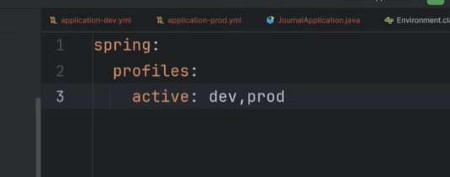

Revision -🡪 https://youtu.be/WRUVixDFI6s?si=6ucRCZR4yl7juiOC